Game Concept Documents

by Team Miru

feat. Chan Il Hwang

Gyu Hyeon Lee

## Miru2.png

## 

GAM100

**Gravity?****3**

High Concept 3

Summary 3

Game Mechanics 4

Characters 4

Environment 5

**Piano Fire****6**

High Concept 6

Summary 6

Game Mechanics 7

Characters 7

Environment 7

**ClockWork()****8**

High Concept 8

Summary 9

Game Mechanics 9

Game Character 10

Environment 10

# Gravity?

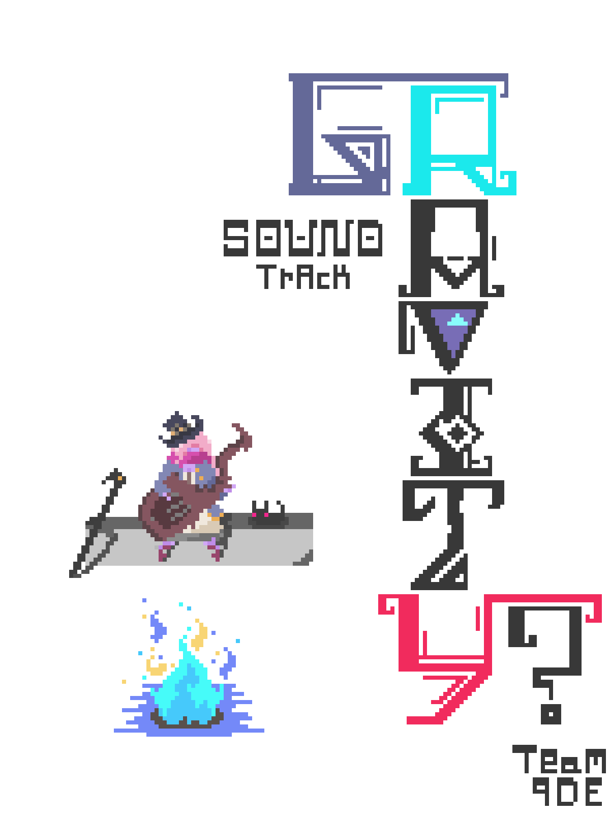

## 01.High Concept

* 1. Gravity? is a 2D isometric game fighting with enemies who can control the gravity freely. Use the floors to avoid these abilities by making yourself heavy or damage your opponents by changing the gravity.

## Summary

* 1. Gravity? is a game that provides the player another way to fight against the creatures instead of just slaying them with sword like old fashioned Zelda-like games. As you don’t have any weapons that game characters typically use, you have to use the environment to use the enemy's power to hurt themselves reversely.

## Game Mechanics

* 1. Interact : Unlike other isometric hack and slash games such as Zelda or Hotline Miami, player can not attack the enemy directly. Instead, player should interact objects in the game.
     1. Floor : Although the character doesn’t have the supernatural abilities like reversing gravity, she can do similar things stepping on particular floors. For example, by stepping on the anti-gravity floor, player can reflect stones thrown by the enemies. Player can also switch positions with the enemy by stepping on the ‘switch’ floor.



* + 1. Pillar : As not enough efforts are not invested to maintain these enormous marble pillars, they are weakened and just ready to fall. Player can damage the enemies by making them to hit one of these and luring them into the place where the pillar is falling.
    2. Health Pond : Place with limited amount of source where player can recover HP by standing in the pond.
  1. Dodge
     1. Without any source to protect you, dodging is the only way to save player’s life. Player should use short dash or long-distance teleport using the character’s staff.

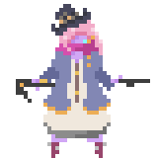

## Characters

* 1. As a guardian of the floating island, Nella, who is the main character of this game, was chosen to protect this island from the enemies who are trying to ruin this sacred place. She can use short dash called ‘Vision Flash’ and quickly move to the location of her staff.

## Environment

* 1. Fantasia, which is the name of this floating island, is full of magical Sci-Fi looking buildings that are mostly impossible in real world. However, the entire island is collapsing away . Player will explore 4 parts of the island based in the main sacred which is located in the middle of the island. Each place consists special floors and pillars with one enemy to fight.

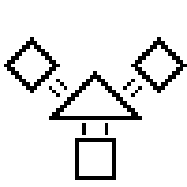

# Piano Fire

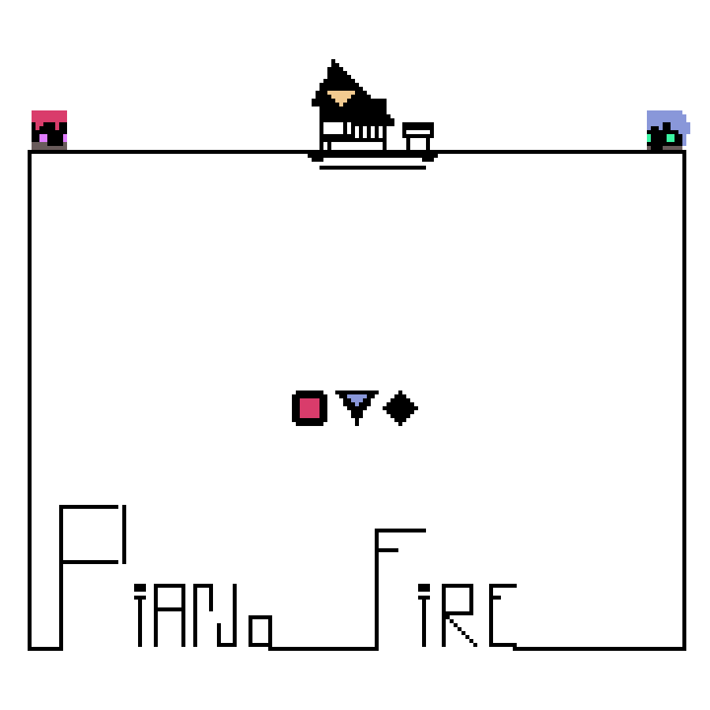

## High Concept

* 1. Piano Fire is a 2D rhythm co-op game. Fill the song by moving instrument to instrument while trying to avoid other player.

## Summary

* 1. In Piano Fire, players will control characters to play various instruments such as piano, drum, or violin to hit the note at the right time. Each note has different shape and color and will be only destroyed if the right player plays the right instrument. Most of all, it is really important to cooperate well because each player can collide, which makes the game hard to complete.

## Game Mechanics

* 1. Keys: Player can control your character by WASD keys to move your character and spacebar to play instrument while your partner use direction keys and enter key. Dash can be done by pressing your moving key twice. 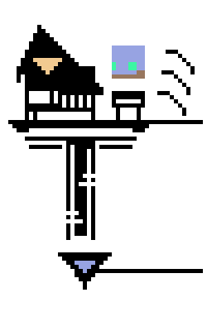
  2. Colliding: As both players can collide each other, they have to dodge by jumping or dashing.
  3. Notes: Each note has different color and shape. For example, if a note is blue-painted triangle, it will be destroyed only if the blue character plays the piano at the right time.



## Characters

* 1. There’s two characters who fill the songs’ missing notes : Red and Blue. Two players will control each character.

## Environment

* 1. Players will move their character at the top of the box while the notes going from right to left. Players are not allowed to get inside the box or fall to the outside.

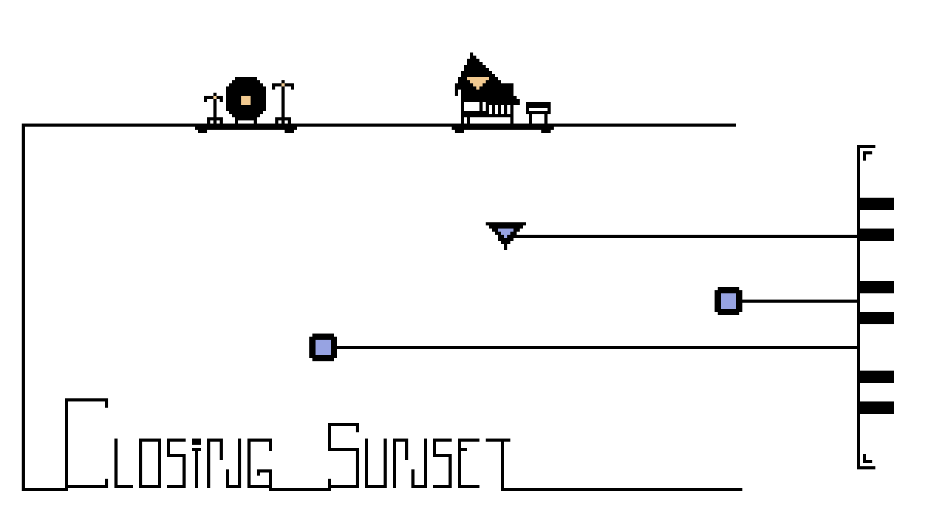

# ClockWork()

## High Concept

* 1. Clockwork() is a 2D action game with a story about a girl who lives in the world after the massive calamity. Think, plan, and execute after numerous trials.

## Summary

* 1. Clockwork() is for the player who wants fast action paced gameplay based on what he or she plans. Players have to plan what objects to link together to complete the level as fast and safe as they can. They also quite a skill to defeat each enemies without dying during the execution based on previous planning.

## Game Mechanics

* 1. Planning : Each level contains various objects that can be connected. When connected objects will start to interact each other. For example, if the player connect enemy and door, the door will be unlocked when the enemy is killed. Player should manage to link well so that they can beat the level as fast as they can.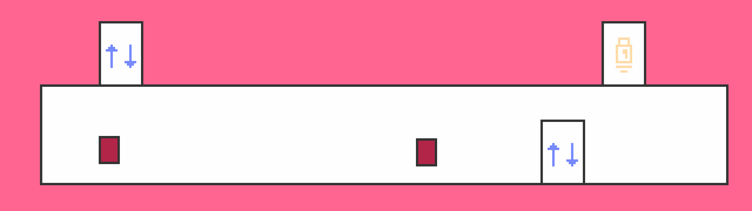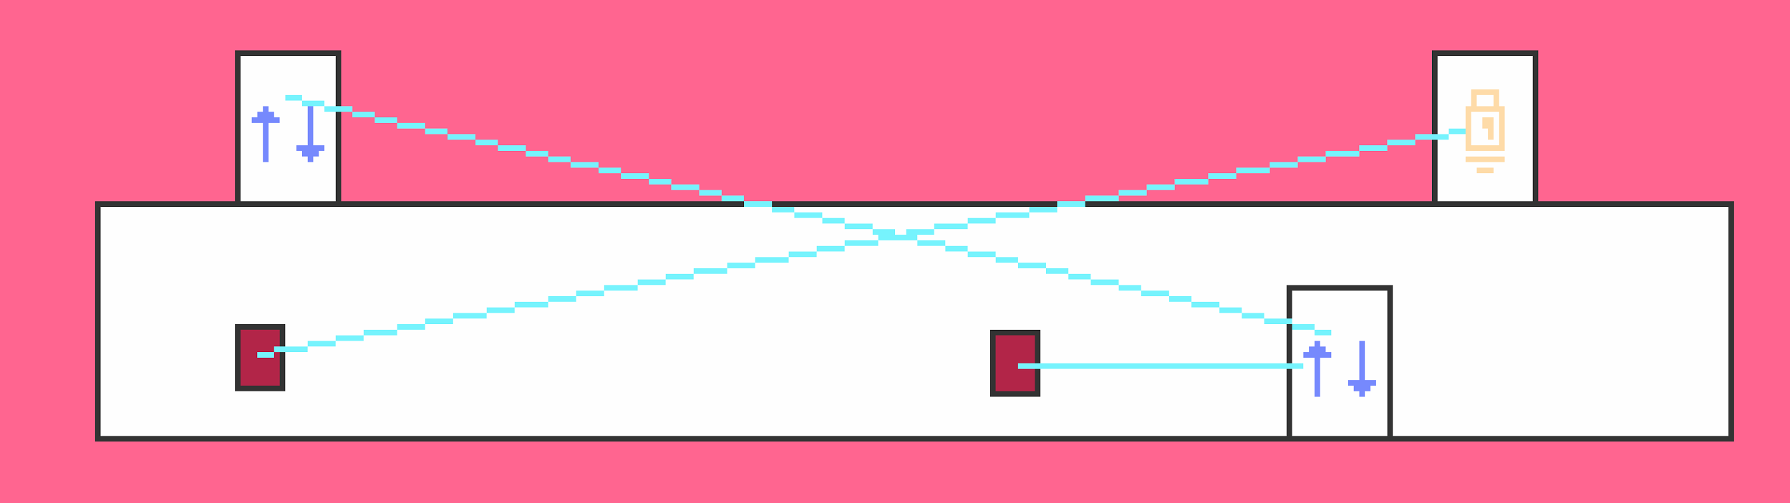
  2. Execute : After planning, player will enter the level based on what they’ve planned. Quite amount of skill is needed to attack the enemies while trying not to get hit. At the end of the level, score will be calculated based on remaining time which is displayed at the bottom side of the game.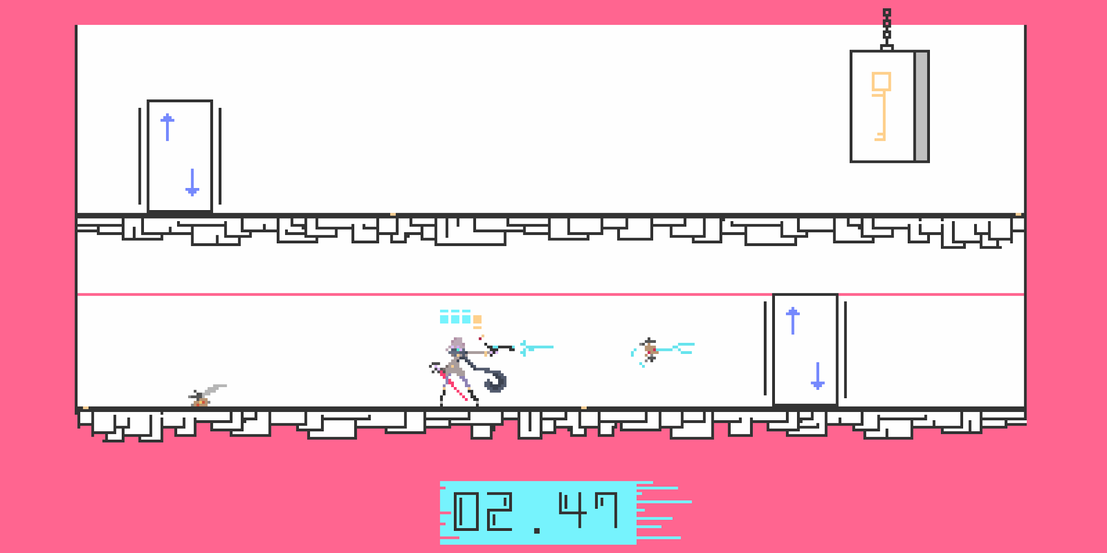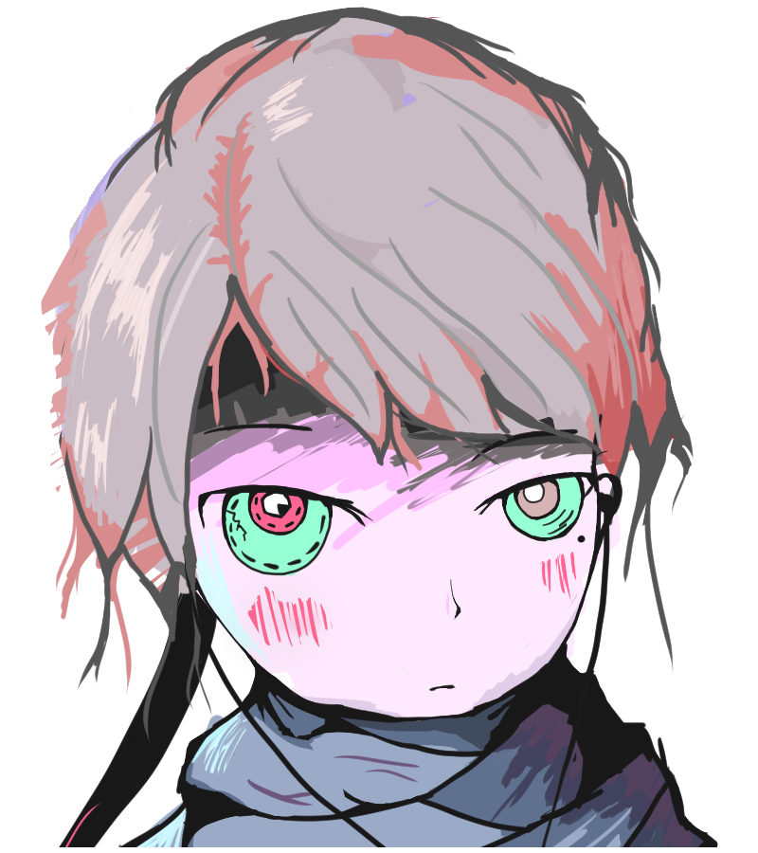

## Game Character

* 1. Our main character Kari is a lone survivor in this planet. She think and behave exactly as the ‘Clockwork’ protocol says. Her only friend is the AI, who helps Kari plan to steal food and water from abandoned supply factories.

## Environment

* 1. Each level takes place in one of the supply factories which are mostly abandoned after the calamity. Factories are full of locked doors, teleportation machines, and robots that are programmed to protect the place.